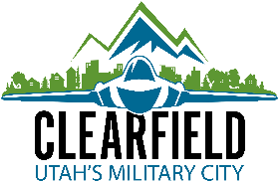
NOTICE OF PUBLIC HEARING TO AMEND FEES IN THE CONSOLIDATED FEE SCHEDULE OF
CLEARFIELD CITY

Notice is hereby given that a public hearing will be held before the Clearfield City Council on Tuesday, June 23, 2026 at 7:00 P.M. in the City Council Chambers, 55 South State, 3rd Floor, Clearfield, Utah, to receive public comment regarding the amending of waste collection fees and excavation permit fees in the Consolidated Fee Schedule.
A copy of the public notice is available on the city’s website: clearfieldcityut.gov, on the Utah Public Notice Website – www.utah.gov/pmn/ and at Clearfield City Hall, 55 South State Street, Clearfield. Additional information is available by contacting Rich Knapp the Finance Manager at 801-525-2720, rich.knapp@clearfieldcity.org, between the hours of 8:00 a.m. and 5:00 p.m., Monday through Friday.
All interested persons shall be given an opportunity to be heard.
Dated this 12th day of June 2026.

/s/Nancy R. Dean, City Recorder

The complete public notice is posted on the Utah Public Notice Website - www.utah.gov/pmn/, the Clearfield City Website – clearfieldcityUT.gov, and at Clearfield City Hall, 55 South State Street, Clearfield, UT 84015. To request a copy of the public notice or for additional inquiries please contact Nancy Dean at Clearfield City, Nancy.dean@clearfieldcityut.gov & 801-525-2714.

